620024600 Power Switch Knob (1) 

620030900 Knob Block A-8 (2)
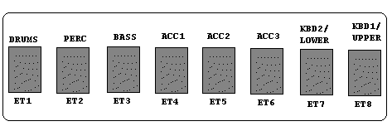
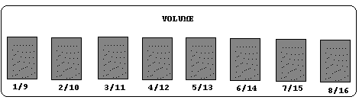

620031000 Knob Block A-3 (2)
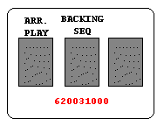

620031100 Knob Block A-1 (2)
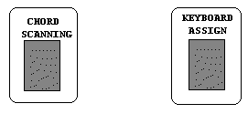

620031200 Knob Block B-7 (2)
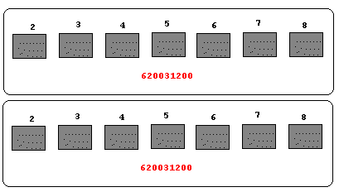

620031300 Knob Block B-5 (1)
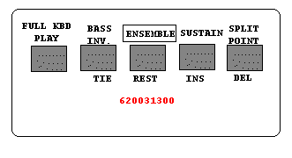

620031400 Knob Block B-2 (1)
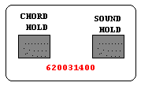

620031500 Knob Block B-1 (1)
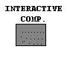

646062600 Slide Pot Knob (1)
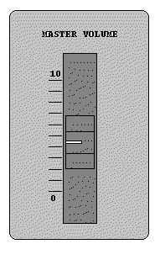

646063100 Knob Block (1)
